Annex X: Human-wildlife conflict and Wildlife crime

Human Wildlife Conflict in General

Incidents of conflicting situations between humans and the wild animals are on the rise. Conflict occurs when wildlife requirements overlap the requirements of human populations. This phenomenon has reached a point where the traditional human-wildlife co-existence practices in Sri Lanka are being breached increasingly. Such human wildlife conflicts (HWCs) can eventually result in the local extirpations of wild species populations, further destruction of habitats, collapsing of ecosystems and even extinction of wild species (Woodroffe, et al. 2005). Although not being the first option, HWC prevention measures practiced in most cases leads to lethal methods of control, whereas management alternatives such as increased public education and improved land use planning should have taken precedence. Further, such conflicts adversely Impact on the human welfare and have economic and social costs. Therefore, it is important to take necessary action at the earliest possibility when indicators of HWCs are recorded. The management of such conflicts in Sri Lanka falls under the preview of the Department of Wildlife Conservation (DWC). While, policy directives on managing human-elephant conflict has already been developed by the DWC, such moves on other conflicting wildlife is still at its infancy. Main species involved in HWCs other than the elephant in Sri Lanka include monkeys (especially the island endemic toque monkey), crocodiles, leopard, birds (such as the peafowl, parakeets and munias, small mammals, especially Rodents (such as the giant squirrel, porcupines, etc.), bats and other medium to large mammals (such as wild boar, spotted deer, sambur, wild buffalo and civets cats (IUCN, 2018). While there is damage to crops such as paddy and vegetables from wildlife such as wild boar, monkeys, peacocks, parakeets and munias and to permanent crops such as coconut and fruit trees from giant squirrels, porcupines and bats, such damages are generally viewed as part and parcel of day-to-day incidents in life and/or cultivations. Human-elephant conflict (HEC), on the other hand is considered differently, possibly due to the inability to address the conflict by villagers and due to the threat to life (IUCN and MMD&E, 2017).

Human-Elephant Conflict
Indicators of Human-Elephant Conflict (HEC) can be divided into impacts on elephants and impacts on humans. Impacts on elephants are, injuries, deaths, and loss and fragmentation of habitat including the shrinking of their range due to the loss of jungle corridors. Impacts on humans are crop damage, property damage, lost opportunity costs, safety concerns, injury and death. Concerns of personal safety are also a psychological impact of human-elephant conflict, resulting in other social consequences. However, no data are available currently to assess crop losses and socio-economic impacts of HEC at finer scales. Three sets of data indicative of HEC were available from the DWC: human deaths, elephant deaths and damages to house and property compensated by the Department. Of these three, human deaths are the most important as an indicator of HEC as a death of a human caused by an elephant is usually considered unacceptable by the public, perceived as the most severe manifestation of the conflict and also leads to public protests and public and political pressure on the DWC (IUCN and MMD&E, 2017).

Summary of data sources
For the national and district level data on the human-elephant conflict we have initially referred to the for Wildlife Management Plan for the Upper Elahera Project (IUCN and MMD&E, 2017), in which data are available for all districts of Sri Lanka, on human deaths due to HEC for 2013 and 2014, house and property damage due to HEC from 2008 to 2014 and elephant death due to HEC from 2010 to 2014.

Further, some more recent data on the human-elephant conflict for districts at the national scale could be retrieved directly from the DWC later and are tabulated and discussed separately. That incudes the two most important indicators of HEC (i.e. number of human deaths, elephant deaths due to HEC) for project related Divisional Secretariat Divisions (DSDs) within the districts for Anuradhapura, Mannar and Vavuniya from 2012 to September 2018.

Human-elephant conflict in Sri Lanka at the District level

Of the 25 Districts in Sri Lanka, HEC occurs in 17, which cover the entire dry zone of the country. The districts with HEC are: Ampara, Anuradhapura, Badulla, Batticaloa, Hambantota, Kandy, Kurunegala, Mannar, Matale, Monaragala, Mullativu, Nuwara Eliya, Polonnaruwa, Puttalam, Ratnapura, Trincomalee and Vavuniya (IUCN and MMD&E, 2017). The ‘Managing Together’ (MT) project landscape is situated in Anuradhapura and Mannar Districts while a southern section of the Vavuniya District also intrudes into the project landscape. HEC is present in all three Districts of the project landscape, as indicated by its indicators, while it is minimal in Vavuniya while considerably high in Anuradhapura (IUCN and MMD&E, 2017). Statistics are discussed below in terms of the three indicators discussed above.

Human deaths
No human deaths were reported from the districts of Mannar, Ratnapura and Vavuniya during 2013-2014. The highest number of human deaths was reported from the Kurunegala District with 20 deaths (Figure 1). Of the districts relevant to the project, Anuradhapura recorded the fourth highest with 14 human deaths. A lesser number of deaths (4) were recorded from Matale (Figure 15). In respect of human deaths HEC was very high in the area belonging to the Anuradhapura District which lies within Trial Landscape 1 during the period of 2013-2014 (IUCN and MMD&E, 2017).
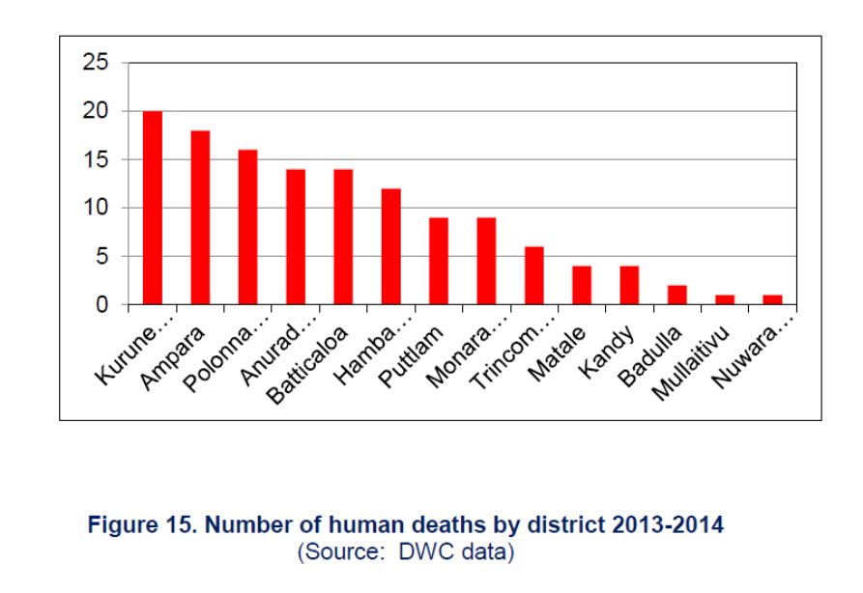
Figure 1. Number of human deaths due to HEC by district during the period of 2013-2014 (source: IUCN and MMD&E, 2017, based on the data from DWC)

House and property damage
Of the Districts with HEC, house and property damages caused by HEC were reported from all except for Mullaitivu District, during the period 2008-2014 (Figure 2). However, this is likely to be because of administrative difficulties because of the ethnic conflict during the period rather than the lack of damage. The highest damage was in Ampara District with 1,190 records. Anuradhapura District was ranked 4th with 632 records, while Mannar and Vavuniya reported the least damage (IUCN and MMD&E, 2017).

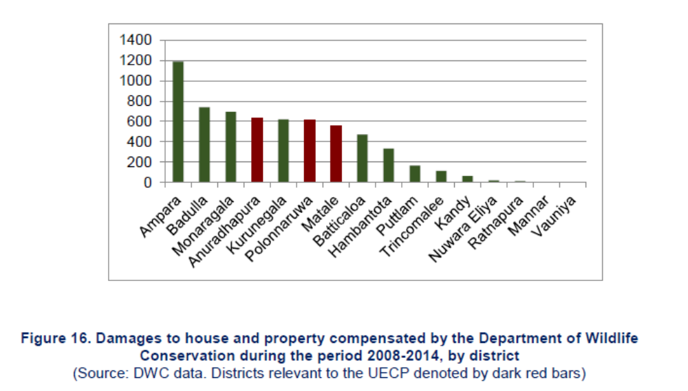
Figure 2. Damages to house and property compensated by the DWC due to HEC by district (source: IUCN and MMD&E, 2017, based on the data from DWC) during the period of 2008-2014

Elephant deaths
Deaths of elephants were recorded from all 17 districts during the period 2010-2014 (Figure 3). The highest number was recorded from the Anuradhapura District with 173 deaths, while Maanar and Vavuniya recorded 20 and 16 deaths respectively. Therefore, with respect to elephant deaths, of the three districts relevant to the project Anuradhapura leads with a very high level of HEC (IUCN and MMD&E, 2017).

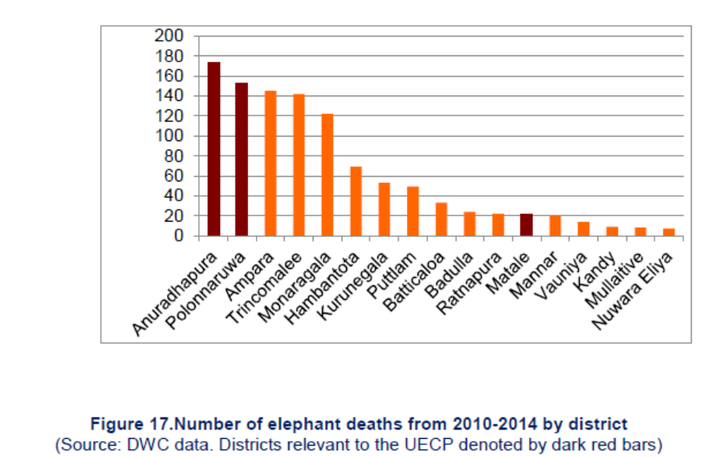
Figure 3. Number of elephant deaths due to HEC by district during the period of 2010-2014 (source: IUCN and MMD&E, 2017, based on the data from DWC)C indicators in relation to MT project Trial Landscapes

Human-elephant conflict in project related Districts at the DSD level

The HEC occurs in 17 districts within the dry zone of the country including Anuradhapura and Mannar. HEC in Anuradhapura district has been far above the other districts within the MT project landscape according to the data published in IUCN and MMD&E (2017)

Human deaths: While no human deaths were reported from Mannar between 2013-2014, Anuradhapura District had the fourth highest number of deaths (14) according to DWC data. With the exception of Nuwaragama Palatha east, all divisional secretariat divisions in the Anuradhapura District: Galenbindunuwewa, Kekirawa, Mihintale, Palugaswewa, Rambewa and Thirappane experience HEC. Of the divisional secretariat divisions in Anuradhapura, Kekirawa had the highest number of human deaths (3) between 2013-2014 according to DWC data, followed by Thirappane (2) and Mihintale (1) (IUCN and MMD&E, 2017).

Elephant deaths: While The highest number of elephant deaths was recorded from the Anuradhapura District with 173 deaths between 2010-2014. With the exception of Nuwaragama Palatha east, all divisional secretariat divisions in the Anuradhapura District: Galenbindunuwewa, Kekirawa, Mihintale, Palugaswewa, Rambewa and Thirappane experience HEC. Of these, Palugaswewa had 22 elephant deaths and Kekirawa had 20 elephant deaths between 2010-2014 according to DWC data (IUCN and MMD&E, 2017).

Damage to housing and properties: With regards to damages reported, Anuradhapura District was again, ranked fourth highest, with 632 records of damage caused to houses and properties by elephants. Within the district, the highest number of incidents were recorded from Kekirawa with 149 and the second highest from Thirappane with 106 between 2008-2014 (IUCN and MMD&E, 2017).

The above data all three HEC indicators between 2008 and 2014 clearly makes Mihintale, Thirappane and Kekirawa DSDs to stand-out within the Anuradhapura district with considerably high levels of HEC, while they are the three main DSDs situated with the Trial Landscape 1 of the MT project. Even among these three DSDs Kekirawa and Thirappane showed a higher level of conflict.

More recent data (2012-to September 2018) collected for two of the above indicators of HEC (Human deaths and Elephant deaths due to HEC) retrieved from the DWC for the main DSDs situated within the three Trial Landscapes of the MT project are discussed below.
In addition to the above three main DSDs within the Trial Landscape 1, the summary below includes five more peripheral DSDs of the same Trial Landscape. They are Rambewa, Kahatagasdigiliya, Nachchadoova, Palugaswewa and Galenbindunuwewa. Additionally, HEC indicator statistics for two major DSDs each for the Trial Landscape 2 (Cheddikulm & Mantai West), and Trial Landscape 3 (Nanaddan & Musali) are also compaired.

Human deaths: According to the Table 4. human death statistics indicate Kakogawa to be the worst DSD in terms of HEC causing 10 human deaths, while Thira pane being second with a total of 9 deaths. None of the other DSDs within the Trial Landscape 1, neither in Trial Landscape 2 and 3 has more than 5 human deaths, while only Nachchadoova had recorded 5 deaths. Even among the districts totals in human deaths due to HEC Anuradhapura leads with 104 deaths over the seven years, while Vavuniya and Mannar has four and five deaths respectively. Among the DSDs in Trial Landscape 2 and 3 Cheddikulam is responsible for the highest number of 4 deaths.
Table 4. Human deaths due to human-wildlife conflict within the “Managing Together” Trial Landscapes at the level of Divisional Secretariat Divisions from 2012 to September 2018 (Data from DWC)
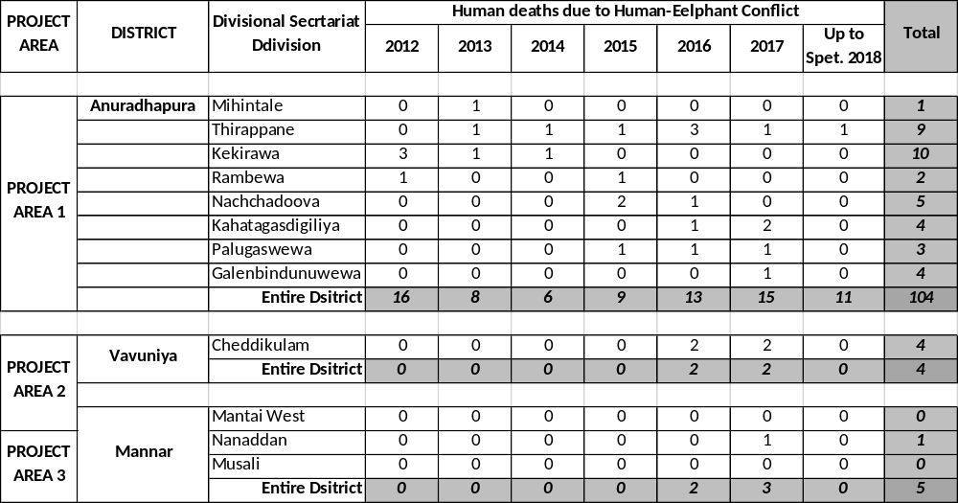

Elephant deaths: Similar to the human deaths, elephant deaths also indicate a remarkably high HEC in Anuradhapura (242) compared to Mannar (29) and Vavuniya (49) in between now and 2012. Further Kekirawa (21), Thirappane (21) and Palugaswewa (17) in Trial Landscape 1 and Cheddikulam (15) in Trial Landscape 2 are showing high levels of conflict.

Table 5. Elephant deaths due to human-wildlife conflict within the “Managing Together” Trial Landscapes at level of Divisional Secretariat Divisions from 2012 to September 2018 (Data from DWC)
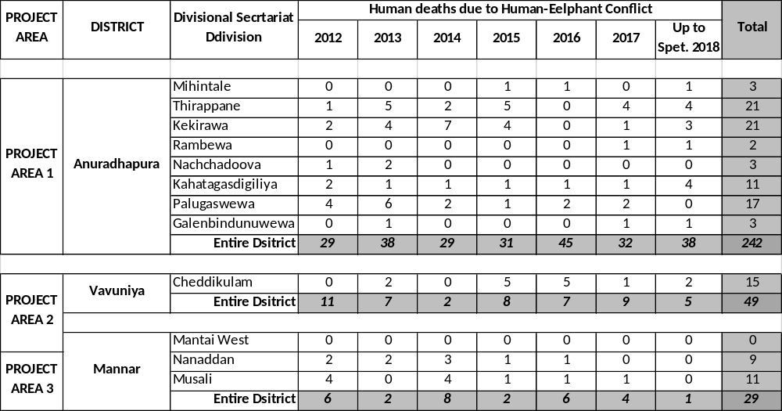

While the information on tables 4 and 5 identifies the hotspots of HEC within the project landscape, both the above indicators illustrate an increasing trend of EHC in 2016-2017 period, which is alarming. Further, the statistics provided in both the tables 4 and 5 supports the proposals for elephant corridors being developed across Kekirawa, Thirappane, Palugaswewa and Nachchadoova (Proposed Elephant Corridor 1 of MT project), as well as in Cheddikulam (Proposed Elephant Corridor 3 of MT project).

Human perceptions on Human-Wildlife Conflicts in Anuradhapura District

Following results are summarised from a grid-based sociological survey conducted predominantly in Anuradhapura District for gathering baseline data for the Upper-Elahera Canal Project. With regards to HWCs, respondents were asked to list three species of animals that caused most problems. Birds (86.3%), monkeys (62.9%), elephants (58.6%) and wild boar (51.2%) topped the list while elephants were the species identified as the first priority by the majority of the people. Insects (25.4%) were also repeatedly mentioned. Domestic animals (11.7%), squirrels (2.7%) and porcupines (0.4%) were rarely listed among the top three (IUCN and MMD&E, 2017).
Damage from wild boar and monkeys is most likely to be directed at home gardens and chena while damage from elephants is more for paddy and from birds for all cultivations. The higher importance shown towards damage from elephants by respondents, suggests greater psychological impact, hence perception of damage and/or severity of damage. The 171 people who had elephants in their area were asked how much of a problem they had with elephants. Many of them (75.4%) felt that elephants caused major problems while moderate problems were reported by 5.3% and minor problems by 16.4% of the respondents. Only five respondents (3.0%) said there were no problems with elephants in their area (IUCN and MMD&E, 2017).

The elephant, considered as one of the important species in the dry zone landscape, needs a large area for its survival. Elephant population of Sri Lanka is currently facing serious threats to its existence due to continuous shrink of favorable habitats, destruction of corridors due to the changes in land use patterns and degradation of the quality of existing habitats. As a result, conflict between Human and Elephant has been rapidly increasing causing property damage; injuries and deaths of both human and elephants. The studies have been suggested that elephants living in fragmented habitats situated in high human use areas consisting of croplands and homesteads area highly vulnerable to coming into conflict with humans. It has been recommended that such habitat patches be linked with corridors to minimize human-elephant conflicts (MoNP&EF, MoA, MoI&WRM, MoLG&PC, MoDM, MoMD&E and MoPA&HA, 2018).

Major threats to Elephants in Sri Lanka (excerpt from Fernando et al., 2011)
The major threat to elephants in Sri Lanka is habitat loss and fragmentation through conversion to settlements and permanent cultivation. The influx of people into areas inhabited by elephants results in increased interaction and conflict, leading to the death of over 200 elephants annually with a trend of increasing numbers (Fig. 4). Most of these elephant deaths are caused by gunshot injuries from farmers defending their crops and trap guns (Table 1). A new addition is ‘hakkapatas’ - a small pressure mine concealed in fruits or vegetables, which shatters the jaw on being bitten down upon. During and in the aftermath of the war, death and injuries of elephants due to landmines were reported in the north and east.

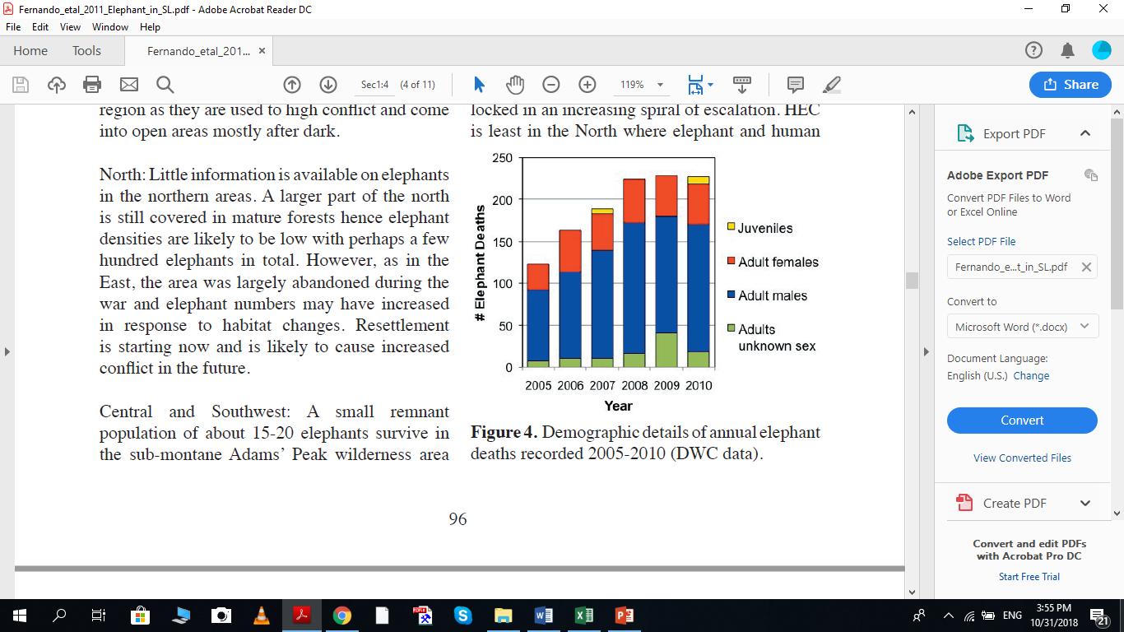
Figure 4. Demographic details of annual elephant deaths recorded 2005-2010 (DWC data).

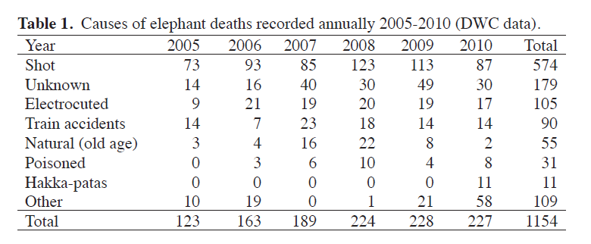
The north-western and north-central areas have the highest levels of HEC in Sri Lanka. With continued conflict, elephants appear to become more accustomed to it, tolerate higher levels of conflict and to raid crops even more frequently and aggressively. Consequently, HEC becomes locked in an increasing spiral of escalation. HEC is least in the North where elephant and human densities are low. HEC appears to be increasing across Sri Lanka and is likely to become severe in the East in the near future. Habitat loss due to developmental activities continues to occur at an ever increasing pace especially with the drive for post war ‘development’. Large scale irrigation schemes based on damming the remaining rivers and attendant irrigated agriculture of extensive areas continue to be designed and implemented. ‘Development’ of large extents of natural habitat currently occupied by elephants for commercial agriculture, by private enterprises, multinational companies and the government, for banana, pineapple, corn, sugar cane, rubber etc. are mooted as part of the development drive. Medium scale development based on the building of small rain fed reservoirs funded by government and non-government agencies also continues apace as do fine scale but widespread development from encroachment of state land for farmsteads by individuals. All these developmental activities result in fragmentation and loss of elephant habitat, and increase in human-elephant interaction and conflict.

The main cause of HEC is crop raiding by elephants. Elephants raid practically all food crops grown (Fernando et al. 2005; Ekanayake et al. 2011). The greatest depredation is of paddy, which is also the most widely cultivated food crop. Others such as corn, sugar cane, finger millet; vegetables such as pumpkin, sweet potato, beans, pulses; and fruits such as banana, water melon and mangoes are among crops that are frequently raided. In recent years, there has been an increasing trend of elephants knocking down coconut palms and teak trees, which cause comparatively high economic losses, hence greater negative perception of elephants. Similarly, damage to house and property from elephants trying to access stored grain is of major concern to people who have to contend with elephants. In the last six years on average 71 people died annually as a consequence of HEC (Fig. 5).

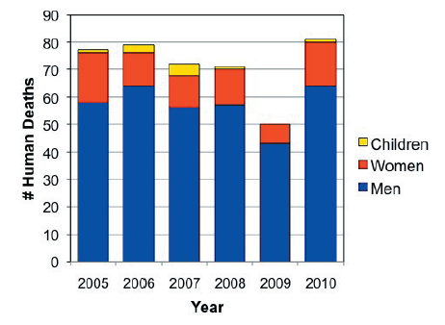
Figure 5. Demographic details of human deaths caused by elephants 2005-2010 (DWC data).

Many human deaths due to elephants are preventable. The causes include drunkenness, walking or riding bicycles and motorbikes in areas with elephants in the night and confrontation of raiding elephants. Some deaths occur during house damage by elephants.

Solutions tried on elephant management and HEC mitigation (excerpt from Fernando et al., 2011)
For over six decades the approach to elephant conservation and HEC mitigation in Sri Lanka has been the restriction of elephants to protected areas under the DWC. A system of protected areas connected by corridors was proposed in 1959 (Somasuntharam et al. 1959), which served as a blue print for management. It was based on the belief that the best habitat for elephants was undisturbed forest - hence the protected areas, and that elephants migrated long distances - hence corridors linking protected areas allowing movement between them. Most of the corridors were never established. The current protected area system under the DWC covers about 13% of the land consisting of a number of isolated parks, the largest of which are Wilpattu (ca. 1500 km2) and Yala (ca. 1000 km2). The Centre for Conservation and Research (CCR) in collaboration with the DWC has so far radio-tracked approximately 50 elephants. The data obtained has shown that elephants in Sri Lanka do not migrate long distances, have well defined home ranges of 50-250 km2 with high fidelity, and that their preferred habitat is disturbed forest (Fernando 2006a; Fernando et al. 2008a). Surveys have shown that over 70% of elephant range and a larger percentage of elephants occur outside DWC protected areas (DWC survey in 2004; Fernando 2006b). The only agency responsible for managing elephants is the DWC, which also is tasked with almost the sole responsibility for mitigating HEC.

The main methods used for the prevention of raiding and to mitigate HEC are – crop guarding, chasing elephants from the vicinity of crop fields and villages, elephant drives, capture-translocation and electric fencing (Fernando 2006a; Fernando et al. 2008b).

Crop guarding: Farmers build and occupy watch huts on the ground or trees during cultivation periods. Shifting cultivation fields in addition are ringed by a thorn and brushwood fence.

Chasing elephants: The government through the DWC distributes elephant thunders (large firecrackers 30 cm x 2.5 cm diameter) to villagers free of charge (Table 2). Where the villagers are unable to chase away elephants, DWC officials are deployed. However, with repeated exposure, elephants get habituated to thunders, become refractory to being chased and react aggressively towards attempted chasing, leading to even more raiding, aggression and escalation of conflict.
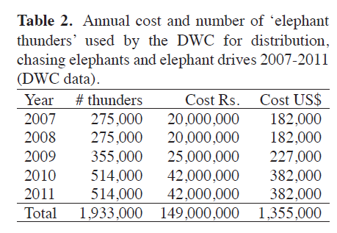

Elephant drives: Elephant drives aim to clear a large area of all elephants. It may involve dozens to hundreds of people and take from days up to a year or more to complete. Small to mid-sized drives are done frequently (Table 3), while the last major drive was conducted in 2005-2006 in the south under the JBIC funded Walawe Left Bank Development Project, taking 1.5 years to complete and costing US$ 1.6 million. Although many drives have been conducted, none has been able to eliminate elephants from a given area (Jayewardene 1994). Drives may cause increase in HEC by making elephants more aggressive. Drives are also detrimental to conservation as herds driven into parks and fenced-in suffer high mortality and morbidity (Fernando 2006a).
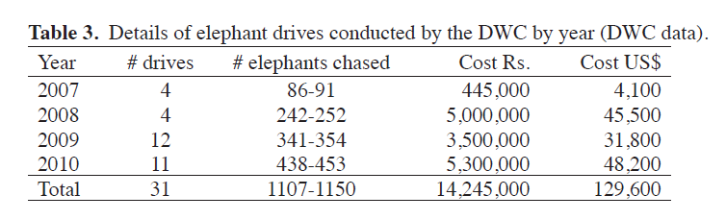
Capture-translocation: In the last 5 years 68 elephants have been translocated in Sri Lanka (Table 4). All elephants subject to capture translocation are adult males. The identified individuals are darted with an anaesthetic, captured, transported by truck to a protected area and released. Monitoring by GPS collars has shown that capture-translocation also does not mitigate HEC as most translocated elephants continue to cause HEC. Sometimes it even results in more intense conflict and its wider propagation. The current recurrent cost to translocate one elephant is around Rs. 270,000 (US$ 2500). Capture-translocation operations have an elephant mortality of approximately 6% due to accidents (Table 4).

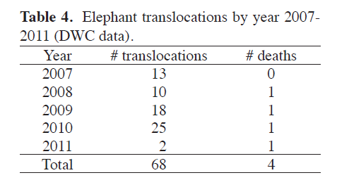

Electric fencing: The DWC has currently deployed over 1200 km of electric fencing. The approximate cost per km is Rs. 500,000 (US $ 4500). A total of 600 km of new electric fencing has been erected under the DWC in 2009-2011. Electric fences are effective only if they are located properly (elephants only on one side of the fence), constructed to appropriate specifications and well maintained. Most electric fences do not fulfil one or more of the above criteria and consequently have short life spans of a few months to about a year. Elephants that challenge and learn to break ineffective fences also tend to break well maintained fences leading to electric fencing becoming unsuccessful. The DWC and a number of non-governmental organizations such as SLWCS, CCR, JICA, CARE, Practical-Action etc. have been promoting community based and managed fences on village boundaries as an alternative more successful approach. In addition, CCR has developed and deployed low-cost temporary fencing for paddy fields.

Capture and domestication: Capturing problem elephants and bringing them into captivity has been tried a few times in the past as a HEC mitigation method. However, it resulted in high mortality of the captured elephants leading to protests from environmental groups. In addition, it cannot be done in a scale relevant to HEC mitigation, for logistic and financial reasons. Capture-domestication is currently not used as an option for HEC management.

Culling: Although over 200 elephants get killed due to HEC annually, these deaths are technically illegal and culling as government policy is not a socio-culturally and politically acceptable option
in Sri Lanka.

Compensation and Insurance: Currently a compensation scheme for death, injury and property damage due to elephants is conducted by the DWC, with Rs. 100,000 (US$ 900) being paid in case of death (Table 5). Compensation and insurance for crop losses have been tried but have not been very successful so far.
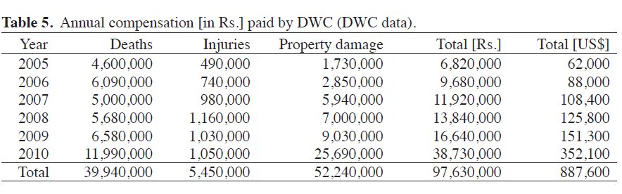

Awareness programs: A few conservation NGOs conduct awareness programs. The Biodiversity and Elephant Conservation Trust has a school program covering many elephant areas (Jayewardene 2011) and Born Free Sri Lanka conducts awareness in selected villages. The DWC also has a few schools and village awareness programs.

Surveys of elephant distribution and HEC, and monitoring of elephants with GPS-collars has clearly demonstrated that the approach of limiting elephants to protected areas has failed and that it is neither effective in conserving elephants or mitigating the HEC. This finding was the basis of a new strategy advocated by the National Policy in 2006. The policy proposes an alternative approach of human-elephant coexistence and management of elephants both in and outside protected areas, with regulation of shifting cultivation, prevention of crop raiding by community based electric fencing, and land use planning. However, affecting a change in paradigm as espoused by the National Policy takes time Creating awareness across all stakeholders in elephant conservation and HEC is critical for its realization.
Excerpt from Fernando et al. (2011) ends here…

Wildlife Crime in Sri Lanka

Wildlife Crime in General
DWC is the main government institution responsible for prevention of wildlife crime in Sri Lanka, as empowered by the Fauna and Flora Protection Ordinance, No.2 of 1937 (FFPO) as amended. Wildlife crime investigation and taking legal actions against offenders are among the main duties of field level wildlife officers (Kumarathunga et al., 2016).

Some of the Major types of offences listed as wildlife crime in the MT project landscape includes;
- Illegally entering and being in wildlife protected areas.
- Poaching and/or Hunting animals (this includes setting of snares, setting of trap guns, and shooting animals, etc.)
- Illegal fishing practices (this includes catching of native fish from natural waterbodies, including poisoning of water to catch crustaceans and fish)
- Illegal felling of trees
- Keeping in possession, transporting or selling bush meat
- Keeping in possession, transporting or selling parts of wild animals (antlers, hide, tusks, bones, specimens, etc.)
- Cutting trees in state lands.
- Sand mining from rivers, streams.
- Collection of forest products and/or species without a permit for subsistence use as well as for smuggling/illegal wildlife trade.
- Killing of wild elephants (this is considered a separate crime with higher punishments than hunting animals without a permit

However, some loopholes have been identified in the existing system that prevents effective enforcement of the law at the ground level. A case-study conducted by Kumarathunga et al., (2016) in Polonnaruwa Assistant Directors’ region of the DWC (which is adjacent to that of the Anuradhapura, in which Trial Landscape 1 is situated), has investigated 50 wildlife crime cases filed before Polonnaruwa and Hingurakgoda magistrate courts by the Minneriya National Park office and Polonnaruwa wildlife rangers’ office. They were filed for 15 different types of offences under the FFPO, and the most common offence was entering and being in wildlife protected areas without prior permission (43%). In 23 cases, the offenders pleaded guilty. The DWC succeeded only in 08 cases after trial and unsuccessful in 16 cases. Three cases have not been decided. The Study found out that absence of a separate officer responsible for raids at field offices, weaknesses of initial investigations, not keeping accurate and complete records of crime incidences, errors in bail bonds, ‘B’ reports, and charge sheets, absence of relevant officials before the courts, evidence handling errors, and conflicting evidences as the major reasons for failures in wildlife crime investigations and bringing offenders before the courts (Kumarathunga et al., 2016).

Wildlife Crime within the Project landscape
Largely caused by the above mentioned causes and due to the limited time we provided them, the DWC could only provide us very patchy information regarding the current status of wildlife crime in the project landscape. They only include a summary on the numbers of wildlife crime reported by field officer to the Anuradhapura Assistant Directors’ region, and the details of some cases representing the DSDs within the project areas 1, 2 and 3.

Summary of wildlife crime in Anuradhapura (2016 – 2018)
Table X. Summary of wildlife crime reported within the Anuradhapura Assistant Directors’ region during the period from 2016 to 2018 (Data from DWC)
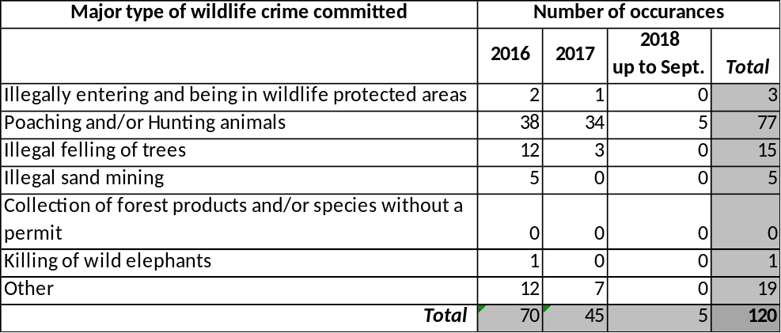
Wildlife crime persecuted in Anuradhapura Assistant Directors’ region of the DWC during the past three years are summarized in the table below. It clearly shows a decrease of wildlife crime from 2019 to 2018, while poaching or hunting has been recorded as the most common crime in all three years.

Punishments for selected wildlife crime within Project Trial Landscapes
Results of thirteen selected court cases are given in the table below, representing four DSDs (two representing the Trial Landscape 1 and one each representing the Trial Landscapes 2 and 3). The table provides evidence for the main species of wildlife being hunted in the area including all three species of deer found within the island, the Indian Wild Boar as well as the Endangered Indian Pangolin within the landscape of Trial Landscape 1 and 2, as well as Globally threatened sea turtles in Trial Landscape 3. Further the fines for persecuted victims are about LKR 17,000.00 in average.

Table Y. Some selected wildlife crime that were persecuted from Kekirawa and Mihintale DSDs in Anuradhapura District and Matai West and Nanaddan DSDs in Mannar District (Data from DWC)
District | DSD | Wildlife crime committed | Fine
Anuradhapura | Kekirawa | Setting snares to hunt animals. | Case still being heard
Anuradhapura | Kekirawa | Keeping a trap gun in possession | Fine of LKR 10,000.00
Anuradhapura | Kekirawa | Keeping meat of a barking deer and an Indian pangolin in possession | Case still being heard
Anuradhapura | Kekirawa | Illegally entering a wildlife protected area | Fine of LKR 15,000.00
Anuradhapura | Kekirawa | Keeping meat of an Indian wild boar in possession | Fine of LKR 15,000.00
Anuradhapura | Kekirawa | Keeping meat of a sambar deer in possession | Fine of LKR 240,000.00
Anuradhapura | Kekirawa | Illegally entering the Ritigala Strict Nature Reserve | Granted bail of LKR 100,000.00
Anuradhapura | Mihintale | Keeping meat and antlers of a spotted deer in possession inside Mihintale Sanctuary | Case still being heard
Mannar | Mantai West | Selling meat of the Indian wild boar | Fine of LKR 15,000.00
Mannar | Mantai West | Hunting a spotted deer inside Madu Road National Park | Case still being heard
Mannar | Nanaddan | Hunting a mouse deer inside Madu Road National Park | Fine of LKR 30,000.00
Mannar | Nanaddan | Keeping meat of a sea turtle in possession | Case still being heard

References

Fernando, P., Jayewardene, J., Prasad, T., Hendavitharana, W., & Pastorini, J. (2011). Current status of Asian elephants in Sri Lanka. Gajah, 35, 93-103.
IUCN and MoMD&E (2017). The Wildlife Management Plan, including Human Elephant Conflict Management and Mitigation, for the Upper Elahera Canal Project (UECP). International Union for Conservation of Nature, Ministry of Mahaweli Development & Environment and Mahaweli Authority of Sri Lanka, Colombo. 392 pp.
Kumarathunga, K. A. U., Prakash, T. G. S. L., & Perera, P. K. P. (2016). Reasons for Failures in Wildlife Crime Investigations and Court Procedures of the Department of Wildlife Conservation in Polonnaruwa Assistant Directors’ Region of Sri Lanka (Qualitative Study). In Proceedings of International Forestry and Environment Symposium (Vol. 21), p. 221.
MoNP&EF, MoA, MoI&WRM, MoLG&PC, MoDM, MoMD&E and MoPA&HA (2018). Climate Smart Irrigated Agriculture Project: Environmental Assessment & Management Framework. Ministry of National Policy & Economic Affairs, Ministry of Agriculture, Ministry of Irrigation & Water Resources Management, Ministry of Local Government & Provincial Councils, Ministry of Disaster Management, Ministry of Mahaweli Development & Environment, and Ministry of Public Administration & Home Affairs, Colombo.
Woodroffe, R., Thirgood, S., & Rabinowitz, A. (Eds.). (2005). People and wildlife, conflict or co-existence? Cambridge University Press, Cambridge

